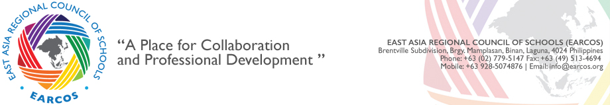EARCOS Global Citizenship Award - School's Notice Form

* Required

School Name *

Student First Name *
(Provide correct spelling of student's name you wish to appear on the EARCOS Global Citizenship Award plaque.)

Student Last Name *
(Provide correct spelling of student's name you wish to appear on the EARCOS Global Citizenship Award plaque.)

<INPUT TYPE=\
The above named student is currently in their penultimate year (11th Grade) at your school and intends to return for their senior (12th Grade) *
YES

NO
If NO, Please explain

Please list the two languages in which the named student is conversant. *

<INPUT TYPE=\
The named student:
• understands the interdependence and interconnectedness of both human and ecological issues.
• demonstrates strong collaborative, problem solving, listening, and consensus building skills.
• strives to be well informed on global issues.
• consistently demonstrates a sense of intrinsic voluntarism.
• exhibits extraordinary leadership skills.
• is committed to being an active participant in the coming year's leadership responsibilities.
• is in "good academic standing".

List below the person completing this form and who acknowledges that the student receiving this award meets the above expectations.

Does your school’s Global Citizenship Award recipient plan to apply for one of six Community Service Grants
Yes

No

Person submitting this form
(This person will be the contact for all future communications regarding this student.)
Complete name *
<INPUT TYPE=\

Job title *

Person submitting email address *

